Training Course Multimedia Fix

Starting in mid-September 2016, the multimedia files in some courses are unable to run on some computers (due to browser and Flash Player updates). If this is a problem in your class, please fix it using one of the options below.

# Option 1: Fix for Google Chrome Browser with Internet Access

1. Open a Google Chrome browser. Navigate to the following URL: <http://www.macromedia.com/support/documentation/en/flashplayer/help/settings_manager04.html>  
   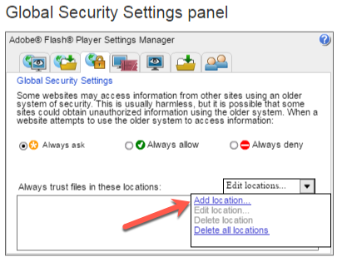
2. Click the Dropdown and select **Add Location**. In the text field, enter the <Exercises> folder **Manually** (should look similar to C:\Exercises\Multimedia), as shown below. **NOTE**: the “Browse for folder…” method does not add the location correctly. This must be performed manually with a copy+paste.
3. 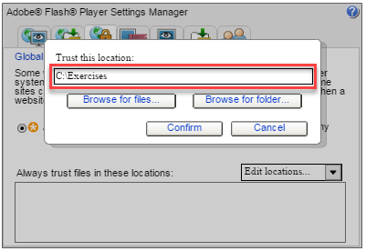
4. Click **Confirm**.
5. 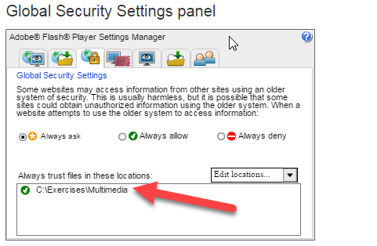
6. You should now be able to Refresh the Google Chrome browser and view the multimedia module.

# Option 2: Fix for Internet Explorer (no internet access)

1. Click the Windows Start button»Control Panel.
2. In the Control Panel window, type flash into the search field and select **Flash Player**.  
   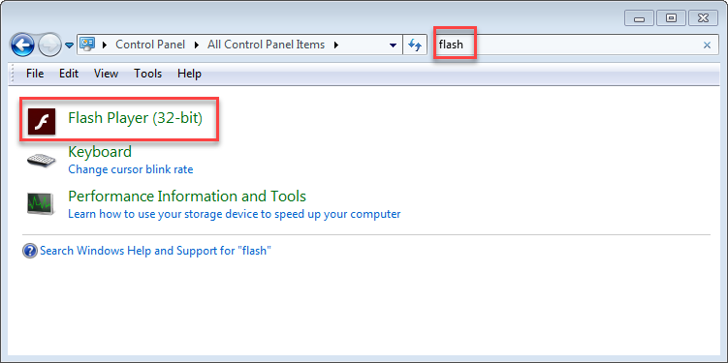
3. Go to the Advanced tab, and click **Trusted Location Settings**.  
   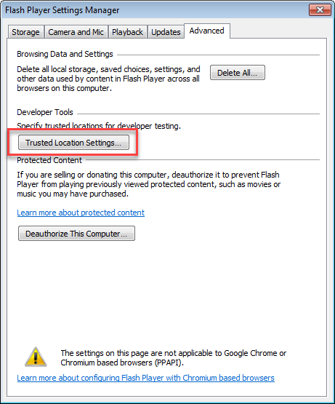
4. Click the **Add** button. Then click the **Add Folder** button, and browse to the <Exercises> folder. Then click the **OK** and **Confirm** buttons.  
   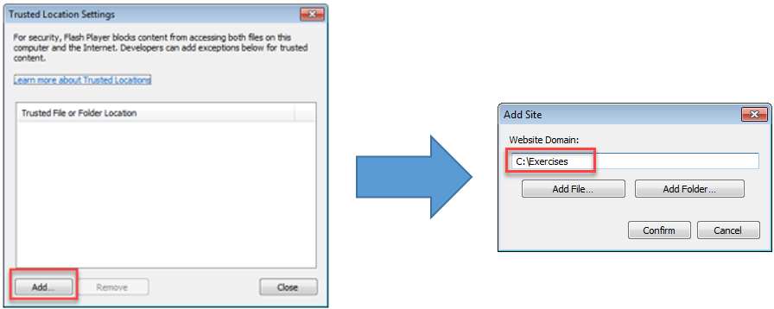
5. You can now launch the multimedia files by going to the Multimedia subfolder, right-clicking the story.html file and selecting **Open with»Internet Explorer**.  
   